 | Hardware Components
Component | Image | Description
Case | 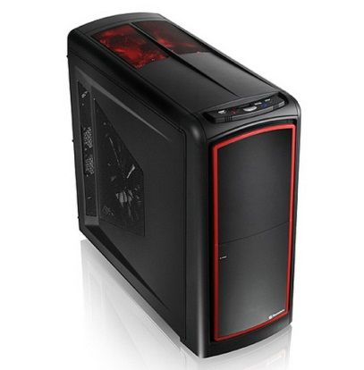 | A computer case also known as System Unit is an enclosure that contains most of the components of the computer.
Heat sink | 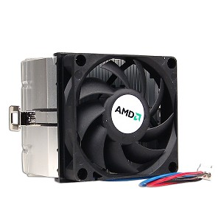 | A heat sink is an electronic device that incorporates either a fan or a peltier device to keep a hot component such as a processor cool.
Power Supply | 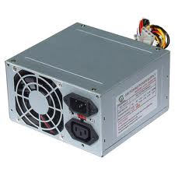 | The PS is an internal hardware component used to supply the components in a computer with power by converting potentially lethal volt alternating current (AC) into a steady low-voltage direct current (DC) usable by the computer.
Fan | 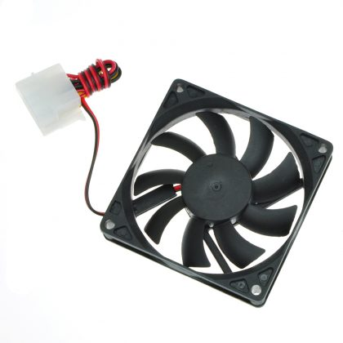 | A hardware device that keeps the overall computer or a computer device cool by circulating air to or from the computer or component
RAM | 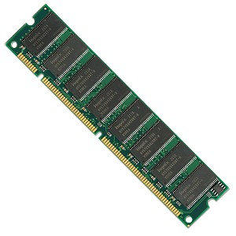 | RAM is a computer storage location that allows information to be stored and accessed quickly from random locations within a memory module. Information is accessed randomly instead of hard drive the computer is able to access the data much faster.
Hard Disk/ Hard Drive | 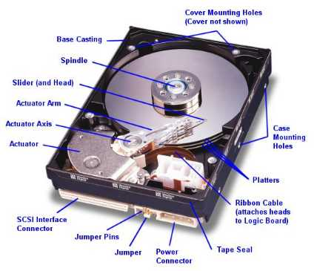 | The hard drive is the computer's main storage media device that permanently stores all data on the computer.
CPU | 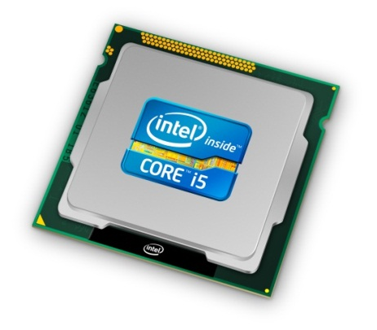 | The computer CPU is responsible for handling all instructions it receives from hardware and software running on the computer.
DVD Drive | 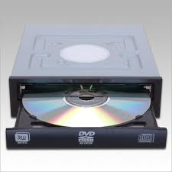 | DVD-ROM is a disc capable of storing large amounts of data on one disc the size of a standard Compact Disc.
Motherboard | 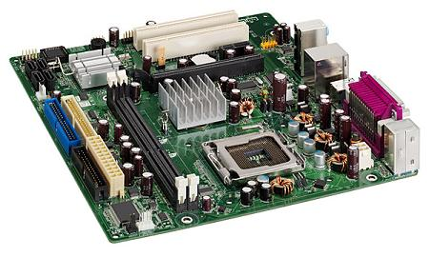 | The motherboard is a printed circuit board that is the foundation of a computer and allows the CPU, RAM, and all other computer hardware components to function and communicate with each other.
GPU | 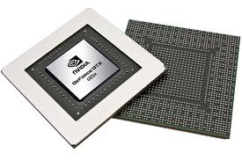 | GPU is a single chip processor located on the video card that handles the processing for 2D or 3D graphics. By having a separate processor on the video card, the computer CPU can handle all other important tasks.
Sound Card | 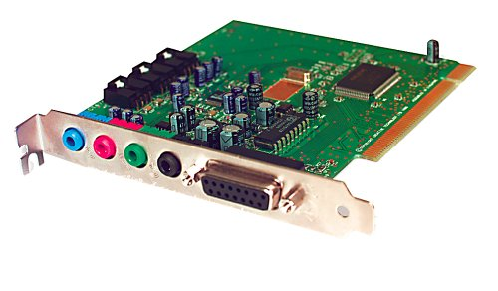 | a sound card is an expansion card or integrated circuit that provides a computer with the ability to produce sounds that can be heard by the user either over speakers or headphones.
Network Interface Card | 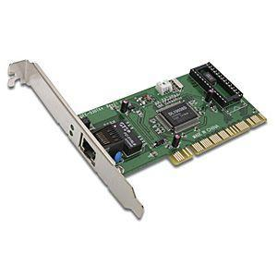 | a NIC is also commonly referred to as an Ethernet card and network adapter and is an expansion card that enables a computer to connect to a network such as a home network or the Internet using an Ethernet cable with a RJ-45 connector.
Ports | 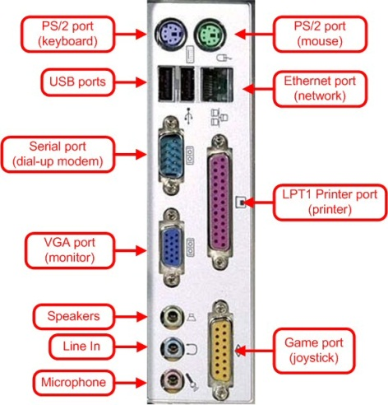 | a hardware port is a hole or connection found on the back of a computer. Hardware ports allow computers to have access to external devices such as computer printers.
BIOS Battery | 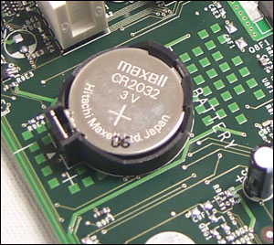 | System BIOS is a chip located on all motherboards that contain instructions and setup for how your system should boot and how it operates.
North Bridge/South Bridge | 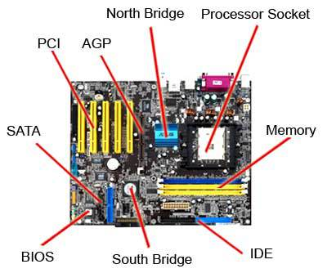 | The Northbridge is an integrated circuit that is responsible for communications between the CPU interface, AGP, and the memory. Unlike the Southbridge the Northbridge is directly connected to these components and acts like a "bridge" for the Southbridge chip to communicate with the CPU, RAM, and graphics controller.
IDE | 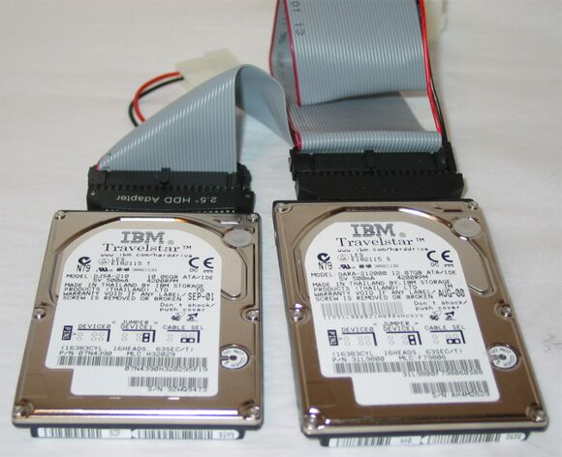 | An IDE interface is an interface for mass storage devices, in which the controller is integrated into the disk or CD-ROM drive.
Cables | 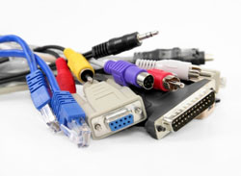 | Cables can be Data cable and Power cable. It connects the computer to the power source.

Reference-
http://www.computerhope.com/jargon

